**Palestine**

**Act Tank**

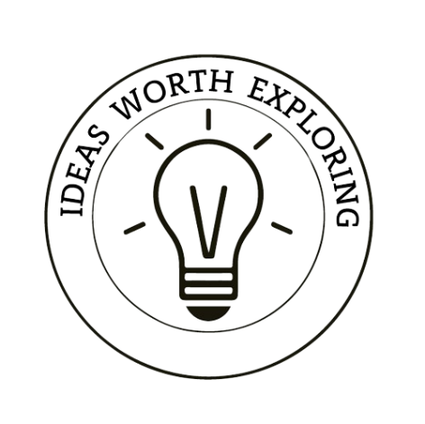**Study Circles**

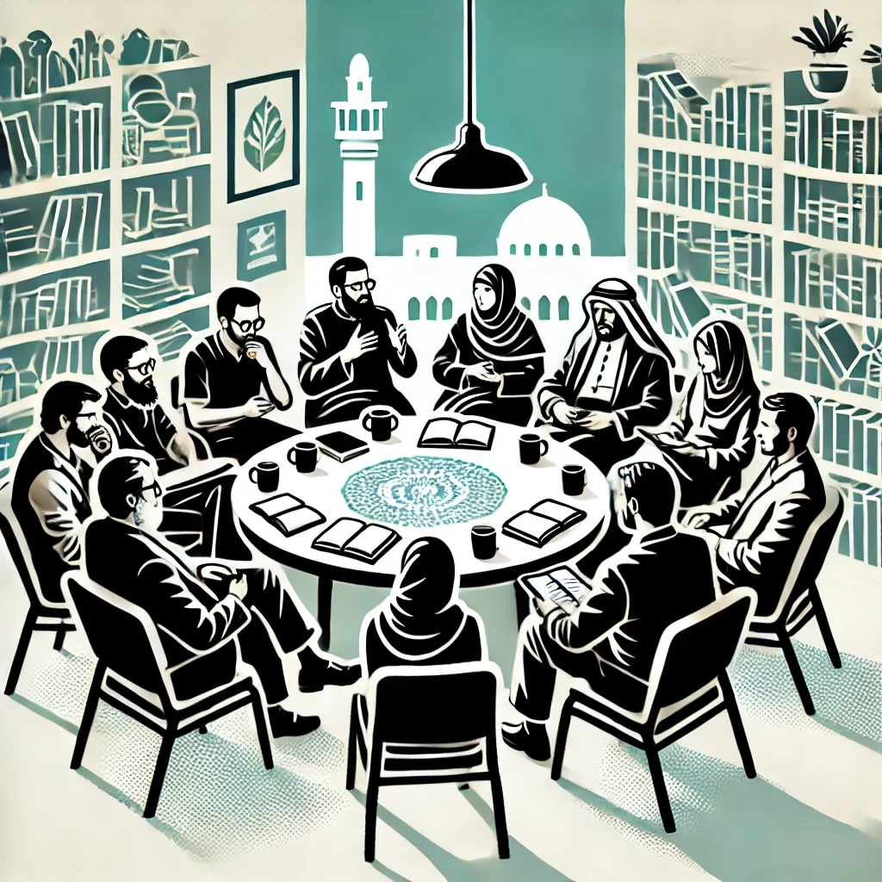

This document provides an overview of how **Study Circles** transform theoretical insights into practical actions. By leveraging insights from the HOPE think tank, Study Circles facilitate collaborative learning and problem-solving on key issues. These small, peer-led groups focus on community-specific topics, combining local knowledge with expert research to address unique challenges. The mission is to empower communities through informed dialogue and collective action, ensuring that solutions are practical and effective. Key functions include organizing discussions, providing resources, facilitating participation, monitoring progress, and integrating feedback to drive continuous improvement and community development.

Contents

1. Function: Study Circles 4

2. 10 Examples of Study Circles 5

3. 10 Success Factors for Study Circles 6

4. 10 Risks associated with Study Circles 7

5. Implementation Steps 8

6. Staff - Roles & Responsibilities 10

7. Case Study: Implementation of Study Circles for Educational Improvement in Palestine 13

# 1. Function: Study Circles

**Definition:** Study Circles are small, peer-led discussion groups designed to facilitate collective learning and problem-solving on specific topics. They leverage the power of dialogue, collaboration, and shared knowledge to address community issues and foster personal and group development.

**Mission:** The mission of the Study Circles department is to promote collaborative learning and community engagement through structured discussions, empowering individuals to contribute to collective problem-solving and decision-making.

**Vision:** Our vision is to create a society where knowledge and ideas are freely shared, and community members are actively involved in addressing local challenges through informed dialogue and collective action.

**North Star:** "Empowering Communities through Collective Learning and Dialogue."

**Objective:** The objective of the Study Circles department is to facilitate effective and inclusive discussions that harness the collective intelligence of community members, fostering a culture of shared learning and collaborative problem-solving. By utilizing the HOPE think tank's insights, Study Circles will translate research findings into actionable community-driven solutions.

**Functions:**

1. **Organizing Study Circles:** Coordinate the formation of study circles around various topics of interest and relevance.
2. **Facilitating Discussions:** Provide training and resources for facilitators to guide productive and inclusive discussions.
3. **Resource Provision:** Develop and distribute materials, guides, and tools to support study circle activities.
4. **Monitoring and Evaluation:** Implement mechanisms to assess the impact and effectiveness of study circles.
5. **Feedback Integration:** Collect and incorporate feedback from participants to continuously improve the program.

# 2. 10 Examples of Study Circles

1. **Civic Engagement Study Circle:** A group focusing on enhancing community involvement in local governance, discussing strategies to increase voter turnout and civic participation.
2. **Environmental Sustainability Study Circle:** Participants explore local environmental issues and brainstorm sustainable practices for households and communities.
3. **Youth Empowerment Study Circle:** Aimed at teenagers and young adults, this circle discusses career planning, leadership skills, and community service opportunities.
4. **Health and Wellness Study Circle:** Focused on promoting physical and mental well-being, covering topics such as nutrition, exercise, and stress management.
5. **Cultural Heritage Study Circle:** A group dedicated to preserving and celebrating local culture, traditions, and history through shared stories and activities.
6. **Economic Development Study Circle:** Participants discuss ways to stimulate local economic growth, support small businesses, and create job opportunities.
7. **Educational Improvement Study Circle:** Teachers, parents, and community members collaborate to enhance the quality of local education, addressing challenges and proposing solutions.
8. **Social Justice Study Circle:** Focused on issues of equality and human rights, this circle seeks to raise awareness and advocate for marginalized groups within the community.
9. **Technology and Innovation Study Circle:** A group that explores the latest technological advancements and their potential applications in local development projects.
10. **Public Safety Study Circle:** Community members and local authorities collaborate to discuss strategies for improving neighborhood safety and emergency preparedness.

# 3. 10 Success Factors for Study Circles

1. **Clear Objectives:** Defining specific goals for each study circle to ensure focused discussions and measurable outcomes.
2. **Effective Facilitation:** Skilled facilitators who can guide discussions, encourage participation, and manage group dynamics.
3. **Diverse Participation:** Including a variety of perspectives by engaging participants from different backgrounds, ages, and expertise.
4. **Supportive Resources:** Providing access to relevant materials, guides, and tools to support informed discussions and learning.
5. **Regular Meetings:** Consistent scheduling of meetings to maintain momentum and continuous engagement among participants.
6. **Open Communication:** Creating an environment where all members feel comfortable sharing their views and experiences.
7. **Action-Oriented Approach:** Focusing on translating discussions into practical actions and solutions that address community issues.
8. **Monitoring and Feedback:** Implementing mechanisms to track progress, gather feedback, and make necessary adjustments to improve the effectiveness of study circles.
9. **Community Support:** Gaining backing from local organizations, authorities, and influencers to enhance the credibility and impact of study circles.
10. **Adaptability:** Being flexible and responsive to the changing needs and interests of participants, ensuring the study circles remain relevant and engaging.

# 4. 10 Risks associated with Study Circles

1. **Lack of Participation:** Insufficient engagement from community members, leading to low attendance and diminished impact.
2. **Poor Facilitation:** Ineffective facilitators who cannot manage discussions, causing unproductive meetings and participant frustration.
3. **Resource Limitations:** Inadequate materials or support, hindering the quality of discussions and learning experiences.
4. **Conflict Among Participants:** Disagreements or personality clashes that disrupt the harmony and focus of the group.
5. **Inconsistent Attendance:** Irregular participation from members, which can impede progress and continuity of discussions.
6. **Overambitious Goals:** Setting unrealistic objectives that cannot be achieved within the given time frame or resources.
7. **Resistance to Change:** Participants or community members who are resistant to new ideas or approaches, limiting the potential for innovative solutions.
8. **Lack of Follow-Through:** Failure to implement actions or solutions discussed in the study circles, leading to disillusionment and reduced motivation.
9. **External Disruptions:** Unforeseen events or external factors (e.g., political unrest, natural disasters) that interrupt the functioning of study circles.
10. **Sustainability Issues:** Difficulty in maintaining long-term interest and support for study circles, affecting their continuity and impact.

# 5. Implementation Steps

**Set-Up Phase:**

1. **Needs Assessment:** Conduct a thorough assessment to identify the specific topics and issues relevant to the community.
2. **Define Objectives:** Establish clear, achievable goals for each study circle based on the identified needs.
3. **Recruit Facilitators:** Identify and train skilled facilitators who can effectively guide the discussions.
4. **Develop Resources:** Create or source the necessary materials, guides, and tools to support study circle activities.
5. **Community Outreach:** Engage with community members and organizations to promote the study circles and encourage participation.
6. **Establish Partnerships:** Form alliances with local institutions, NGOs, and authorities to support the initiative.
7. **Set Up Logistics:** Arrange venues, schedule regular meetings, and ensure all logistical aspects are in place.
8. **Pilot Program:** Launch a pilot study circle to test the process, gather feedback, and make initial adjustments.
9. **Feedback Mechanisms:** Implement systems to collect feedback from participants during the pilot phase.
10. **Refine Program:** Use the feedback to refine and improve the study circle model before broader implementation.

**Operational Phase:**

1. **Launch Study Circles:** Officially start the study circles, inviting community members to participate.
2. **Ongoing Facilitation:** Provide continuous support and training for facilitators to ensure effective management of discussions.
3. **Resource Distribution:** Regularly update and distribute new materials and resources to participants.
4. **Monitor Attendance:** Keep track of participant attendance and engagement to identify and address any issues early.
5. **Encourage Participation:** Foster an inclusive and welcoming environment to maintain high levels of participation.
6. **Document Discussions:** Keep detailed records of discussions, decisions, and actions taken during the meetings.
7. **Evaluate Impact:** Regularly assess the impact of the study circles on participants and the community.
8. **Adjust Strategies:** Make ongoing adjustments to strategies and approaches based on evaluation findings.
9. **Promote Successes:** Publicize the successes and achievements of the study circles to motivate participants and attract new members.
10. **Sustain Engagement:** Develop strategies to keep participants engaged and motivated over the long term.

**Review and Adaptation Phase:**

1. **Periodic Reviews:** Conduct regular reviews of the study circle program to assess overall effectiveness.
2. **Feedback Collection:** Continuously collect and analyze feedback from participants to identify strengths and areas for improvement.
3. **Update Objectives:** Revise the objectives of the study circles as needed to align with evolving community needs.
4. **Refresher Training:** Provide periodic refresher training for facilitators to enhance their skills and effectiveness.
5. **Resource Enhancement:** Continuously update and expand the resources and materials available to participants.
6. **Stakeholder Meetings:** Hold meetings with key stakeholders to discuss progress and gather input.
7. **Adjust Logistics:** Make any necessary adjustments to meeting times, locations, and formats to improve accessibility and convenience.
8. **Expand Reach:** Explore opportunities to expand the study circle program to additional topics or new community segments.
9. **Sustain Funding:** Secure ongoing funding and resources to ensure the sustainability of the study circles.
10. **Celebrate Achievements:** Regularly celebrate and recognize the achievements and contributions of participants to maintain motivation and engagement.

# 6. Staff - Roles & Responsibilities

1. **Program Director:**
   * **Main Role:** Oversee the entire Study Circles initiative.
   * **Key Responsibilities:**
     + Develop strategic plans and objectives.
     + Coordinate with community leaders and stakeholders.
     + Ensure the overall effectiveness and sustainability of the program.
   * **Example:** The Program Director will liaise with local government officials to align study circle topics with community development plans.
2. **Facilitator Trainer:**
   * **Main Role:** Train and support facilitators.
   * **Key Responsibilities:**
     + Develop and deliver training programs.
     + Provide ongoing support and coaching to facilitators.
     + Monitor facilitator performance and provide feedback.
   * **Example:** The Facilitator Trainer will conduct monthly workshops to enhance facilitation skills and address any challenges facilitators face.
3. **Community Outreach Coordinator:**
   * **Main Role:** Promote study circles and engage the community.
   * **Key Responsibilities:**
     + Develop outreach strategies to recruit participants.
     + Foster relationships with local organizations and community groups.
     + Organize promotional events and activities.
   * **Example:** The Community Outreach Coordinator will host information sessions at community centers to attract new participants.
4. **Logistics Manager:**
   * **Main Role:** Manage logistical aspects of the program.
   * **Key Responsibilities:**
     + Arrange venues and schedule meetings.
     + Ensure the availability of materials and resources.
     + Handle administrative tasks related to study circles.
   * **Example:** The Logistics Manager will secure meeting spaces in local libraries and ensure all necessary equipment is available.
5. **Research Analyst:**
   * **Main Role:** Provide research support for study circles.
   * **Key Responsibilities:**
     + Develop and distribute topic-specific research materials.
     + Analyze data and feedback from study circles.
     + Assist in evaluating the impact of study circles.
   * **Example:** The Research Analyst will compile background information on environmental issues for an upcoming study circle on sustainability.
6. **Facilitators:**
   * **Main Role:** Guide and manage study circle discussions.
   * **Key Responsibilities:**
     + Prepare and lead discussions.
     + Foster an inclusive and respectful environment.
     + Ensure that discussions remain focused and productive.
   * **Example:** Facilitators will guide a study circle on health and wellness, ensuring all participants have the opportunity to contribute.
7. **Monitoring and Evaluation Specialist:**
   * **Main Role:** Assess the effectiveness of study circles.
   * **Key Responsibilities:**
     + Develop evaluation frameworks and tools.
     + Collect and analyze data on study circle outcomes.
     + Report findings and recommend improvements.
   * **Example:** The Specialist will create surveys to gather participant feedback and measure the impact of study circles on community engagement.
8. **Resource Developer:**
   * **Main Role:** Create and curate materials for study circles.
   * **Key Responsibilities:**
     + Develop discussion guides and resource packets.
     + Curate relevant articles, videos, and other materials.
     + Update and expand the resource library.
   * **Example:** The Resource Developer will create a guide on civic engagement for a study circle focused on increasing voter turnout.
9. **Participant Liaison:**
   * **Main Role:** Serve as a point of contact for participants.
   * **Key Responsibilities:**
     + Address participant questions and concerns.
     + Facilitate communication between participants and facilitators.
     + Support participant engagement and retention.
   * **Example:** The Participant Liaison will follow up with members who missed meetings to keep them informed and engaged.
10. **Marketing Specialist:**
    * **Main Role:** Develop and implement marketing strategies.
    * **Key Responsibilities:**
      + Create promotional materials and campaigns.
      + Manage social media and online presence.
      + Track and analyze marketing efforts.
    * **Example:** The Marketing Specialist will design flyers and social media posts to advertise upcoming study circle topics and events.

# 7. Case Study: Implementation of Study Circles for Educational Improvement in Palestine

#### **Section 1: Introduction**

Welcome to this comprehensive case study, where we illustrate how the Study Circles department within HOPE's ACT TANK successfully implemented a project to improve educational quality in Palestine. This study highlights the journey from inception to successful implementation, emphasizing the use of detailed reports and insights provided by HOPE's think tank. Through this narrative, we demonstrate the practical application of our research and the tangible benefits it brings to local communities.

#### **Section 2: Project Kickoff**

**Month 1: Setting the Stage**

At the Study Circles office, Layla, the Program Director, gathered her team to discuss the Educational Improvement Study Circles initiative. These initiatives aimed to foster collaborative problem-solving among teachers, parents, and community members to enhance the quality of local education. Omar, the Research Analyst, outlined initial steps for data collection and community engagement. Challenges included establishing trust with local educators and overcoming skepticism about new approaches. Key actions involved planning community engagement strategies, conducting preliminary assessments, and aligning project goals with stakeholders. By the end of the first month, the groundwork was firmly established, with strong relationships built, critical issues identified, and a clear plan in place.

#### **Section 3: Set-Up Phase**

**Month 2: Needs Assessment and Stakeholder Engagement**

The team, led by Layla and Omar, conducted a comprehensive needs assessment to identify specific educational challenges that the study circles could address. The Community Outreach Coordinator, Fatima, engaged key stakeholders, including government officials, community leaders, and educational experts. Resources, including funding, materials, and expert facilitators, were secured by Hassan, the Logistics Manager. A detailed curriculum was developed, tailored to the identified needs. Logistical planning ensured venue selection, scheduling, and participant invitations. Marketing and outreach efforts were launched to ensure maximum participation.

**Month 3: Resource and Facilitator Preparation**

Ahmed, the Resource Developer, created and sourced necessary materials, guides, and tools to support study circle activities. Training sessions for facilitators were conducted by Noor, the Facilitator Trainer, to ensure they were well-prepared and knowledgeable about the study circle content. A pilot study circle was run to identify potential issues and make adjustments before the full rollout.

#### **Section 4: Operational Phase**

**Month 4: Study Circle Delivery**

Study circles were officially launched, inviting community members to participate. Facilitators guided the discussions, ensuring active participation and inclusive dialogue. Real-time feedback was collected to address issues immediately, facilitated by the Monitoring and Evaluation Specialist, Nabil. The Facilitator Trainer, Noor, provided ongoing support to maintain high-quality delivery. Interactive activities and group discussions enhanced practical learning, supported by the Research Analyst, Omar. Resources were distributed to all participants, coordinated by Hassan, the Logistics Manager. Networking opportunities were facilitated for participants to connect and share experiences.

**Month 5: Follow-up and Documentation**

Follow-up sessions were scheduled to reinforce learning, led by the Participant Liaison, Amina. All study circle activities, feedback, and outcomes were documented for future reference. A support helpline was established for participants to seek assistance. Mechanisms were implemented to track the progress of participants, overseen by Nabil, the Monitoring and Evaluation Specialist.

#### **Section 5: Review and Adaptation Phase**

**Month 6: Evaluation and Impact Analysis**

Post-study circle evaluations assessed the effectiveness and gathered feedback. The impact of the study circles on participants' skills and knowledge was analyzed by Nabil, the Monitoring and Evaluation Specialist. Feedback from participants and facilitators was integrated into future study circle planning. Areas for improvement were identified, and the study circle content and delivery methods were updated accordingly. Stakeholders reviewed outcomes and provided insights for further improvements. Resource adequacy was assessed, and allocations were adjusted as needed.

**Month 7: Best Practices and Scalability**

Best practices and successful strategies from the study circles were documented for future replication. Plans for scaling successful study circle models to larger or more diverse audiences were developed by Fatima, the Community Outreach Coordinator. Long-term support mechanisms for participants were established to ensure sustained application of the skills and knowledge gained. Detailed reports on the study circles' outcomes, impact, and lessons learned were prepared to share with stakeholders and funders.

#### **Section 6: Final Outcomes**

**Month 8: Achieving Success**

The Educational Improvement Study Circles significantly improved collaborative problem-solving among teachers, parents, and community members, enhancing the quality of local education. The pilot projects demonstrated that these educational practices could be effectively implemented in Palestine. Challenges included ensuring the sustainability of solutions and maintaining community support. Key actions involved final reporting, planning future projects based on lessons learned, and ongoing community engagement. This marked the successful completion of the initial phase, showcasing tangible benefits and setting a foundation for future initiatives.

#### **Conclusion**

The Educational Improvement Study Circles enhanced collaborative problem-solving and addressed educational challenges, ensuring sustainable educational practices. Through rigorous data collection, community involvement, and strategic policy development, the Study Circles department bridged the gap between theoretical insights and practical applications, improving the quality of education for local communities in Palestine.