**Palestine**

**Act Tank**

**Debate Events**

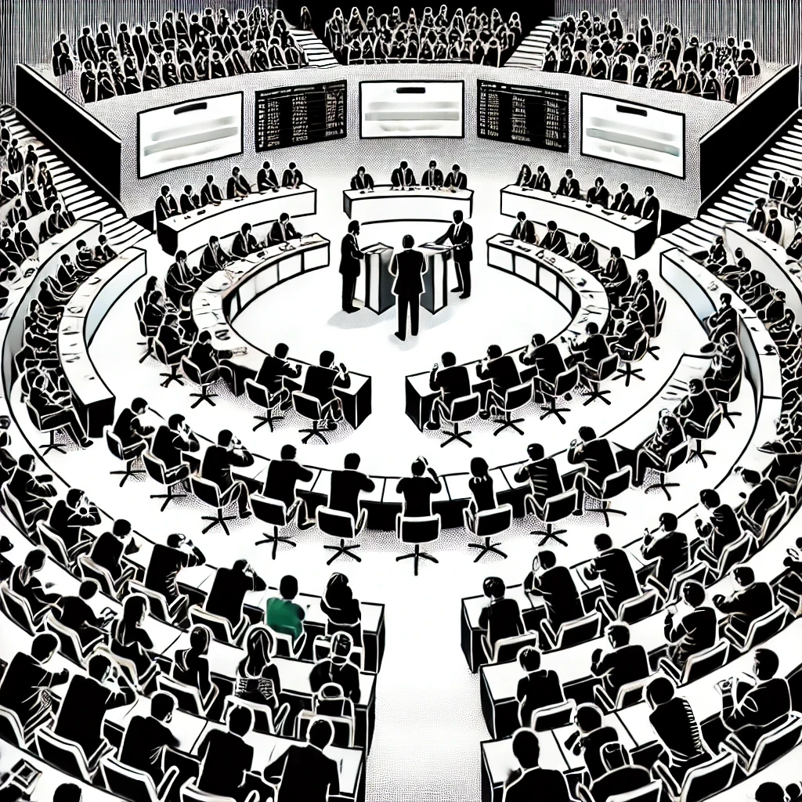

This document provides an overview of how **Debate Events** transform theoretical insights into practical discourse. These events focus on enhancing critical thinking and public speaking skills by engaging participants in structured debates on various topics. The mission is to utilize global insights from the HOPE think tank to foster informed discussions within Palestine's socio-economic and cultural contexts. By bridging the gap between knowledge and practice, these debates drive intellectual development and community engagement. Key functions include organizing debates, providing training, selecting relevant topics, ensuring effective moderation, and engaging with the community to promote meaningful dialogue and understanding.

Contents

1. Function: Debate Events 4

2. 10 Examples of the Debate Event 5

3. 10 Success Factors for Debate Event 6

4. 10 Risks associated with Debate Event 7

5. Implementation Steps 8

6. Staff - Roles & Responsibilities 11

7. Case Study: Implementation of Urban Development Debates in Palestine 14

# 1. Function: Debate Events

**Definition:** A Debate Event is a structured contest of argumentation between two teams or individuals on a particular topic, aiming to enhance critical thinking, public speaking skills, and informed decision-making.

**Mission:** The mission of the Debate Event department is to foster a culture of informed discourse and critical thinking among participants, encouraging them to engage with diverse perspectives and articulate their viewpoints effectively.

**Vision:** The vision is to create a dynamic platform for constructive debates that empower participants with the skills to engage in meaningful dialogue, promote understanding, and drive societal progress.

**North Star:** "Empowering voices, fostering understanding, driving progress."

**Objective:** The objective of the Debate Event department is to provide a platform that leverages the insights from the HOPE think tank to facilitate debates on critical issues, thereby enhancing participants' analytical abilities and contributing to the overall intellectual development of the community.

**Functions:**

1. **Organize Debate Competitions:** Coordinate and manage regular debate events on various topics, ensuring broad participation and high standards of discourse.
2. **Training and Workshops:** Provide training sessions and workshops to improve participants' debating skills, critical thinking, and public speaking abilities.
3. **Topic Selection and Research:** Curate relevant and impactful debate topics, supported by thorough research and data from the HOPE think tank.
4. **Judging and Feedback:** Develop a robust system for judging debates and providing constructive feedback to participants.
5. **Community Engagement:** Engage with schools, universities, and community organizations to promote the importance of debate and critical thinking.

# 2. 10 Examples of the Debate Event

1. **National Policy Debates:** Organize debates on national policies such as healthcare reform, education strategies, and economic policies to encourage public engagement and diverse viewpoints.
2. **Environmental Issues Debates:** Host debates on topics like climate change, renewable energy, and conservation efforts to raise awareness and stimulate critical discussions on environmental challenges.
3. **Cultural and Social Issues Debates:** Facilitate debates on social topics such as gender equality, cultural preservation, and social justice to promote understanding and empathy among participants.
4. **Educational Debates:** Collaborate with schools and universities to conduct debates on educational topics, such as the effectiveness of standardized testing and the impact of technology in education.
5. **Technology and Innovation Debates:** Organize debates on the implications of emerging technologies, data privacy, and the ethics of artificial intelligence to engage participants with the technological landscape.
6. **Global Affairs Debates:** Host debates on international relations, global conflicts, and diplomacy to foster a global perspective and understanding of international issues.
7. **Health and Wellness Debates:** Facilitate discussions on public health topics, mental health awareness, and wellness practices to promote healthy lifestyles and informed decision-making.
8. **Economic Development Debates:** Organize debates on economic strategies, entrepreneurship, and job creation to stimulate innovative ideas for economic growth.
9. **Youth and Future Generations Debates:** Engage young people in debates about their future, focusing on issues like education, employment, and social media influence to empower them to shape their future.
10. **Community-Specific Debates:** Tailor debates to address local community issues, such as urban development, public safety, and local governance, ensuring relevance and immediate impact.

# 3. 10 Success Factors for Debate Event

1. **Clear Objectives:** Define clear goals for each debate event to ensure focus and relevance, aligning with the overall mission and vision of the department.
2. **Effective Moderation:** Employ skilled moderators who can manage the flow of discussion, enforce rules, and ensure a respectful and productive debate environment.
3. **Comprehensive Training:** Provide thorough training for participants, including workshops on debate techniques, public speaking, and research skills to enhance performance.
4. **Diverse Topics:** Select a wide range of debate topics that are relevant, current, and engaging, covering various aspects of society, politics, economy, and culture.
5. **Inclusive Participation:** Encourage broad participation from different demographics, including students, professionals, and community members, to ensure diverse perspectives.
6. **Robust Judging Criteria:** Develop clear and fair judging criteria to evaluate debates, providing constructive feedback to help participants improve.
7. **Effective Promotion:** Utilize various channels to promote debate events, ensuring high visibility and engagement from the target audience.
8. **Strong Partnerships:** Build partnerships with educational institutions, community organizations, and media outlets to enhance the reach and impact of debate events.
9. **Feedback Mechanism:** Implement a system for collecting feedback from participants and attendees to continuously improve the quality and effectiveness of debate events.
10. **Follow-Up Activities:** Organize follow-up activities such as discussion forums, publications, and community projects to sustain the impact of debates and encourage ongoing dialogue.

# 4. 10 Risks associated with Debate Event

1. **Participant Bias:** There is a risk of biased viewpoints dominating the debates, which can limit the diversity of perspectives and diminish the overall quality of discussions.
2. **Poor Moderation:** Ineffective moderation can lead to chaotic debates, where participants talk over each other or fail to stay on topic, reducing the value of the event.
3. **Inadequate Preparation:** Participants who are not well-prepared may struggle to present their arguments effectively, leading to unbalanced debates and a lack of depth in discussions.
4. **Audience Disengagement:** If topics are not engaging or relevant to the audience, there is a risk of low attendance and participation, reducing the overall impact of the event.
5. **Technical Issues:** Technical difficulties, such as problems with sound systems, video equipment, or online platforms, can disrupt the flow of debates and affect the experience for both participants and the audience.
6. **Security Concerns:** Debates on controversial topics might attract individuals with disruptive intentions, posing security risks to participants and attendees.
7. **Resource Constraints:** Limited resources, such as funding, venue availability, and volunteer support, can hinder the organization and execution of high-quality debate events.
8. **Reputational Risk:** Any incidents of unprofessional behavior, biased moderation, or poor organization can damage the reputation of the Debate Event department and the broader HOPE think tank.
9. **Legal Issues:** Debates that touch on sensitive or defamatory topics may lead to legal challenges, requiring careful management to avoid potential litigation.
10. **Participant Burnout:** Frequent and intense debate events can lead to participant fatigue and burnout, impacting their willingness to engage in future activities.

# 5. Implementation Steps

**Set-up Phase:**

1. **Define Objectives:** Clearly outline the goals and objectives for the Debate Event department, ensuring alignment with the HOPE think tank’s mission and vision.
2. **Create a Planning Committee:** Establish a dedicated team responsible for planning and organizing debate events, including members with expertise in event management, moderation, and topic research.
3. **Develop a Curriculum:** Design a comprehensive curriculum for debate training, covering essential skills such as public speaking, argumentation, and critical thinking.
4. **Select Initial Topics:** Identify a list of relevant and engaging debate topics, backed by research and data from the HOPE think tank.
5. **Secure Venues:** Find and book suitable venues for hosting debate events, ensuring they meet logistical and technical requirements.
6. **Establish Partnerships:** Build partnerships with educational institutions, community organizations, and media outlets to support and promote debate events.
7. **Develop Judging Criteria:** Create a clear and fair system for judging debates, including criteria for evaluating arguments, presentation, and overall performance.
8. **Recruit Moderators:** Identify and train skilled moderators to manage debate events effectively.
9. **Launch Promotional Campaign:** Implement a multi-channel promotional campaign to raise awareness about upcoming debate events and encourage participation.
10. **Pilot Event:** Organize a pilot debate event to test the format, gather feedback, and make necessary adjustments before launching a full series.

**Operational Phase:**

1. **Schedule Regular Events:** Establish a calendar of debate events, ensuring a consistent schedule that allows for adequate preparation and promotion.
2. **Conduct Training Sessions:** Regularly host training sessions and workshops to improve participants’ debating skills and prepare them for upcoming events.
3. **Manage Registrations:** Implement an efficient system for managing participant registrations, ensuring clear communication and coordination.
4. **Facilitate Research:** Provide resources and support for participants to conduct thorough research on debate topics, utilizing the HOPE think tank’s insights.
5. **Coordinate Logistics:** Ensure all logistical aspects of debate events are well-coordinated, including venue setup, technical support, and hospitality.
6. **Engage with Community:** Actively engage with schools, universities, and community organizations to foster a culture of debate and critical thinking.
7. **Monitor and Evaluate:** Continuously monitor and evaluate debate events, collecting feedback from participants and attendees to improve future events.
8. **Document Outcomes:** Record and publish the outcomes of debates, highlighting key arguments and conclusions to inform broader discussions.
9. **Recognize Achievements:** Celebrate and recognize the achievements of participants, awarding prizes and certificates to outstanding debaters.
10. **Maintain Partnerships:** Sustain and expand partnerships with supporting organizations to enhance the reach and impact of debate events.

**Review and Adaptation Phase:**

1. **Collect Feedback:** Gather comprehensive feedback from participants, moderators, and attendees after each debate event.
2. **Analyze Data:** Analyze feedback and performance data to identify strengths, weaknesses, and areas for improvement.
3. **Adjust Training Programs:** Modify training programs based on feedback to better address participants' needs and improve skill development.
4. **Revise Topics:** Periodically review and update debate topics to ensure they remain relevant, engaging, and reflective of current issues.
5. **Enhance Judging Criteria:** Refine judging criteria to ensure fairness and clarity, incorporating feedback from judges and participants.
6. **Improve Logistics:** Identify and address any logistical challenges encountered during events, streamlining processes for future debates.
7. **Strengthen Security:** Review and enhance security measures to ensure the safety of participants and attendees.
8. **Expand Outreach:** Develop new strategies to reach wider audiences and encourage broader participation in debate events.
9. **Update Promotional Strategies:** Revise promotional campaigns to reflect the latest trends and effectively engage the target audience.
10. **Conduct Periodic Reviews:** Hold regular review meetings with the planning committee to discuss progress, share insights, and plan future actions.

# 6. Staff - Roles & Responsibilities

1. **Event Coordinator**
   * **Main Role:** Oversee the planning and execution of debate events.
   * **Key Responsibilities:**
     1. Schedule and organize debate events, including logistics and technical support.
     2. Liaise with venues, suppliers, and partners to ensure smooth operations.
     3. Manage event budgets and resources efficiently.
   * **Example:** Successfully coordinated a national debate competition, ensuring seamless logistics and high participant satisfaction.
2. **Training Director**
   * **Main Role:** Develop and oversee training programs for participants.
   * **Key Responsibilities:**
     1. Design comprehensive training curricula on debate techniques and public speaking.
     2. Conduct workshops and training sessions for participants.
     3. Evaluate the effectiveness of training programs and make improvements.
   * **Example:** Implemented a new training module that increased participants' debate performance scores by 30%.
3. **Moderator**
   * **Main Role:** Facilitate and manage the flow of debate events.
   * **Key Responsibilities:**
     1. Ensure debates run smoothly and adhere to established rules.
     2. Manage time effectively and intervene when necessary to maintain order.
     3. Provide impartial guidance and support to participants.
   * **Example:** Moderated a high-stakes debate on climate policy, ensuring a balanced and respectful discussion.
4. **Research Analyst**
   * **Main Role:** Conduct research to support debate topics and provide background information.
   * **Key Responsibilities:**
     1. Curate and synthesize relevant data and insights from the HOPE think tank.
     2. Provide participants with comprehensive research briefs.
     3. Identify emerging trends and issues for future debate topics.
   * **Example:** Produced an in-depth research report that was used as a primary resource in a debate on economic reform.
5. **Community Engagement Officer**
   * **Main Role:** Foster relationships with community organizations and educational institutions.
   * **Key Responsibilities:**
     1. Promote debate events to schools, universities, and local groups.
     2. Organize outreach activities to encourage diverse participation.
     3. Gather community feedback to improve event relevance and impact.
   * **Example:** Successfully engaged three local high schools to participate in a regional debate series.
6. **Marketing and Communications Manager**
   * **Main Role:** Develop and execute marketing strategies for debate events.
   * **Key Responsibilities:**
     1. Create promotional materials and campaigns across multiple channels.
     2. Manage social media presence and online engagement.
     3. Monitor and analyze marketing effectiveness and adjust strategies accordingly.
   * **Example:** Launched a social media campaign that doubled event attendance compared to previous years.
7. **Technical Support Specialist**
   * **Main Role:** Provide technical support for debate events.
   * **Key Responsibilities:**
     1. Set up and manage audio-visual equipment and online platforms.
     2. Troubleshoot technical issues during events.
     3. Ensure all technical aspects meet the highest standards.
   * **Example:** Effectively managed the technical setup for a hybrid in-person and virtual debate event.
8. **Volunteer Coordinator**
   * **Main Role:** Recruit, train, and manage volunteers for debate events.
   * **Key Responsibilities:**
     1. Develop volunteer recruitment and training programs.
     2. Coordinate volunteer activities and schedules.
     3. Recognize and appreciate volunteer contributions.
   * **Example:** Built a robust volunteer network that provided essential support for a major debate tournament.
9. **Financial Manager**
   * **Main Role:** Oversee financial planning and management for the department.
   * **Key Responsibilities:**
     1. Develop and manage budgets for debate events and programs.
     2. Monitor expenditures and ensure financial accountability.
     3. Identify and secure funding opportunities and sponsorships.
   * **Example:** Secured a grant that funded the expansion of debate programs into new regions.
10. **Evaluation Specialist**
    * **Main Role:** Assess the effectiveness and impact of debate events.
    * **Key Responsibilities:**
      1. Develop evaluation frameworks and tools.
      2. Collect and analyze data on participant performance and event outcomes.
      3. Provide recommendations for continuous improvement.
    * **Example:** Conducted a comprehensive evaluation that led to the refinement of debate judging criteria.

# 7. Case Study: Implementation of Urban Development Debates in Palestine

### **Section 1: Introduction**

This case study illustrates how the Debate Events department within HOPE's ACT TANK successfully implemented urban development debates aimed at enhancing urban planning in Palestine. It highlights the journey from inception to successful implementation, demonstrating the practical application of research and the tangible benefits it brings to local communities.

### **Section 2: Project Kickoff**

**Month 1: Setting the Stage**

At the Debate Events office, Amal, the Event Coordinator, gathered her team to discuss the Urban Development Debates initiative. This project aimed to foster critical thinking and informed decision-making among stakeholders in urban planning. Khalid, the Research Analyst, outlined initial steps for data collection and community engagement. The main challenges included establishing trust with local urban planners and overcoming skepticism. Key actions involved planning community engagement strategies, conducting preliminary assessments, and aligning project goals with stakeholders. By the end of the first month, the groundwork was firmly established, with strong relationships built, critical issues identified, and a clear plan in place.

### **Section 3: Set-Up Phase**

**Month 2: Needs Assessment and Stakeholder Engagement**

The team conducted a comprehensive needs assessment to identify specific urban development issues. Key stakeholders, including government officials, urban planners, and community leaders, were identified and engaged. Resource allocation involved securing necessary funding, materials, and expert facilitators. A detailed curriculum was developed, tailored to the identified needs. Logistical planning ensured venue selection, scheduling, and participant invitations. Marketing and outreach efforts were launched to ensure maximum participation.

**Month 3: Technology and Trainer Preparation**

All necessary technology and equipment were set up and tested. Training sessions for facilitators ensured they were well-prepared and knowledgeable about the debate content. Participant pre-assessment surveys were conducted to tailor the debate topics accordingly. A pilot debate was run to identify potential issues and make adjustments before the full rollout.

### **Section 4: Operational Phase**

**Month 4: Debate Execution**

Debates were executed as planned, ensuring active participation. Real-time feedback was collected to address issues immediately. Facilitator support was provided to maintain high-quality delivery. Interactive activities and group discussions enhanced practical learning. Resources were distributed to all participants. Networking opportunities were facilitated for participants to connect and share experiences.

**Month 5: Follow-up and Documentation**

Follow-up sessions were scheduled to reinforce learning. All debate activities, feedback, and outcomes were documented for future reference. A support helpline was established for participants to seek assistance. Mechanisms were implemented to track the progress of participants.

### **Section 5: Review and Adaptation Phase**

**Month 6: Evaluation and Impact Analysis**

Post-debate evaluations assessed the effectiveness and gathered feedback. The impact of the debates on participants' skills and knowledge was analyzed. Feedback from participants and facilitators was integrated into future debate planning. Areas for improvement were identified, and the debate content and delivery methods were updated accordingly. Stakeholders reviewed outcomes and provided insights for further improvements. Resource adequacy was assessed, and allocations were adjusted as needed.

**Month 7: Best Practices and Scalability**

Best practices and successful strategies from the debates were documented for future replication. Plans for scaling successful debate models to larger or more diverse audiences were developed. Long-term support mechanisms for participants were established to ensure sustained application of the skills and knowledge gained. Detailed reports on the debates' outcomes, impact, and lessons learned were prepared to share with stakeholders and funders.

### **Section 6: Final Outcomes**

**Month 8: Achieving Success**

The urban development debates significantly improved critical thinking and informed decision-making among stakeholders in urban planning. The pilot projects demonstrated that these educational practices could be effectively implemented in Palestine. Challenges included ensuring the sustainability of solutions and maintaining community support. Key actions involved final reporting, planning future projects based on lessons learned, and ongoing community engagement. This marked the successful completion of the initial phase, showcasing tangible benefits and setting a foundation for future initiatives.

### **Conclusion**

The urban development debates enhanced critical thinking and informed decision-making, addressing community needs and ensuring sustainable urban planning practices. Through rigorous data collection, community involvement, and strategic policy development, the Debate Events department bridged the gap between theoretical insights and practical applications, improving the quality of urban planning for local communities in Palestine.